Voyager preferences

Be sure the following preferences are set before beginning ReCAP transfers using macros. Otherwise macros will not function properly. This is how to check or set preferences.

Go to the Options menu and click on the Preferences … option. The following window will appear, with the “General” tab active.

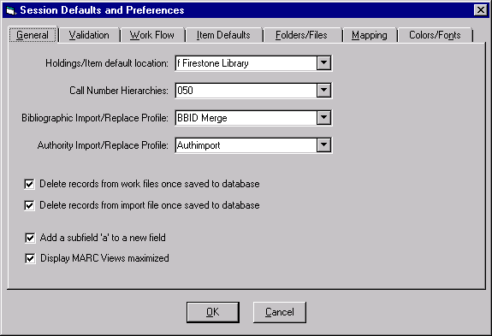
Move from tab to tab as shown, and make sure that the specified settings are correct on the computer you are using. Leave other settings as you find them. To check or uncheck boxes, click in the box. To choose from a dropdown menu (signaled by a small triangle to the right of the box), click on the arrow and scroll to select the choice specified in this document. Blank is at the top of the list.
Check in this box.

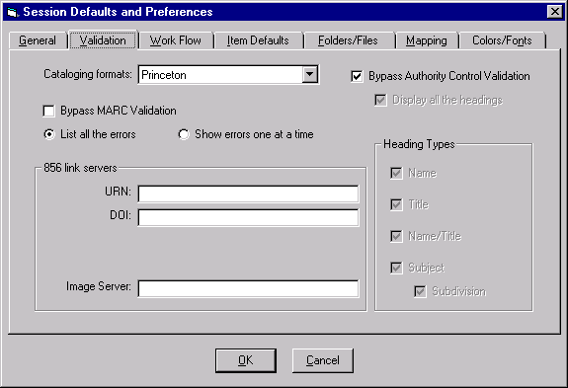
Cataloging formats: Princeton.
Check in Bypass Authority Control Validation.
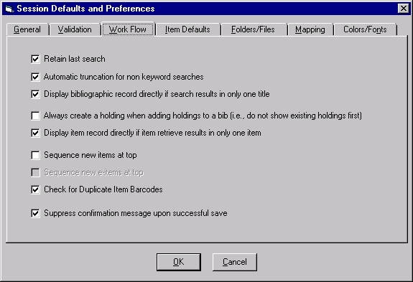
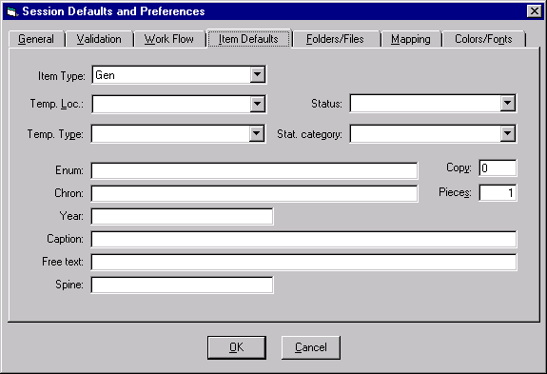
Check in all boxes except these two.
Item Type = Gen.
Status = [Blank]

